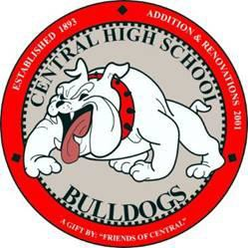Final Transcript Request for Class of 2022 CHS Graduates

Central High School 423 E. Central

Springfield, MO 65802 Registrar’s Office Phone: 417-523-9617 / Fax: 417-523-9682

If you are a graduate from the Class of 2020 Central High School and would like to request a transcript or immunization records, please complete the information below and allow 5 business days to process your request. **Submit completed request along with a copy/picture of your photo ID to:** [**clmccrite@spsmail.org**](mailto:clmccrite@spsmail.org)

All previous graduated classes should request their transcript from sps.org, *Community* tab, *Alumni* tab, *Transcripts* link. Instructions and the form are posted including contact information for district records.

All GED requests are handled by Missouri’s Department of Elementary and Secondary Education at (573) 751-3504.

**Student Name:**

First Middle Last Maiden

**Student ID: Date of Birth:** / /

**Phone: Email Address:**

**Requesting:**

Official Transcript Unofficial Transcript Include ACT Scores Immunization Records

**Send To:** Name and Address of Institution/Organization

Email or Fax if preferred:

Signature of Requesting Person (must be the person making the request unless 17 years or under):

X Date:

If Guardian For a Minor, Print Name:

First Middle Last

OFFICE USE ONLY: DATE RECEIVED: DATE SENT: BY: MAIL FAX EMAIL